

Project Title:
“Car Rental Services”

Course: Application of Computer and Information Technology
Instructor: Miss Ramsha Khalid

Group Members:
Name: Roll numbers:
- Muhammad Tayyab 2025-CS-263
- Awais Asif 2025-CS-261
- Muhammad Asad 2025-CS-253
- Mubeen Fatima 2025-CS-283
- Ayesha Jehangir 2025-CS-262
- Adeena Fatima 2025-CS-265

Department of Computer Science,
University of Engineering and Technology, Lahore
Date: December 29, 2025

Table of Contents
Table of Contents 2
Executive Summary 4
Project Objectives and Scope 4
Project Objective 4
Project Scope 4
Project Flow 5
Site Structure and Navigation 6
Home Page 6
Sign In/Up Page 7
Contact us Page 9
Services Page 9
Design Choices and Layout 10
Assets Used 11
Images Used 12
Font Used 13
Colors Used 13
Publishing and Running of Web 14
Brief Guide to Publish Web 14
Reflection of Project 14
Improvements 15
Improvement Task Flow 15
15

Executive Summary
The name of the project is the Car Rental Services. This is a group project and a real life web base project in which we have made a rent a car website and the name of the website is Drive Now. The main reason to choose this project is that this is a real world problem in which our ideas can contribute a lot in serving the humanity. In this project we will make only front end of a rent a car service website using programing languages HTML and CSS. After that we will make excel sheet have dummy data perform calculation on this data and apply different formulas on it and then make chart of that data. Then we will make a presentation using Microsoft Power Point to present our project. In this step we have added some charts on the slide and the data of the website and different objective that have explained in this document. Then we made an animation video of 60 second using different software. Then we made a word document all the data is also present on the git hub. All this is the summary of our project.

Project Objectives and Scope
The project objectives and the scope is given as following.

Project Objective
The main objective of this project is to develop a user-friendly car rental website that allows overseas and local customers to rent a car directly from our company without the involvement of any agents. The website aims to provide a convenient, reliable, and time-saving platform where users can book rental cars online using their mobile phones or any device with an internet connection.
This system is especially helpful for overseas customers who want to arrange transportation before arriving in the country, ensuring they can travel home or to their destination immediately upon arrival. The website also supports customers who require a car for short-term or long-term rental periods, making the entire rental process simple and efficient.

Project Scope
Online Car Booking
Customers can view available cars, select rental dates, and book a vehicle online at any time.

Support for Overseas Customers
Users from other countries can book a car before arriving, eliminating the need for agents or middlemen.

Mobile and Internet Accessibility
The website is accessible through mobile phones, tablets, and computers with any internet connection.

Rental Period Selection
Customers can rent cars for short-term or long-term periods according to their needs.

Car Details Display
The system displays car information such as model, price, availability, and rental conditions.

User-Friendly Interface
A simple and intuitive front-end design to ensure ease of use for all users.

Cost Transparency
Rental prices are clearly shown, helping customers avoid hidden charges.

Project Flow

Website
The process starts with the website, which acts as the main source of information. All important details such as services offered, pricing, special deals, and company information are published here for users to access easily.
Word Document
After the content is prepared on the website, it is converted into a Word document. This makes the information easier to edit, review, and keep as an official record for future use.
Excel Sheet
Key information from the Word document is then organized into an Excel sheet. This helps in managing data like prices, customer details, bookings, and reports in a clear and structured way.
Presentation
The data arranged in Excel is used to create a presentation. This presentation helps explain the information visually during meetings, project discussions, or reviews with stakeholders.
Animated Video
The presentation is then turned into an animated video to make the content more engaging and easier to understand, especially for a wider audience.
LinkedIn Post
In the final step, the animated video is shared as a LinkedIn post. This helps promote the service, attract potential customers, and increase the company’s online presence.

Site Structure and Navigation
Our website the main objective of the project is to make a website that make easier for the overseas to rent a car from our company directly without ang agent. They can also rent a car if they are on the way to our country and they need a rent service to go home. If they want to get a car on rent for some days they can also do that online with the help of their mobile phone that have any internet connection

Home Page
the home page of the website is the main page that is also called the first view page of the website when the users click on the link of the website, he will go to the home page of the website. In this page some information about the company is shown and then go down there are many pictures of the cars that are the part of our company the user can see all about the car on the home page. The home page is the most attractive page of our website because first impression is the last impression for the clients the home page have also a navigation bar that have all other options to go to the other pages in these buttons, we have provided the links of the other pages of the website the home page have also header and footer.
The header of the website contains the navigation bar of the website the navigation bas of the website is the header of the website. The navigation bar consists on logo on its left side and the right side of the navigation bar of the home webpage have three buttons for the home, services, about us, contact us, sign in, sign up pages.
The footer of the home page contains some information about the company.
Link: https://awaisasif808.github.io/AICT-lAB-PROJECT-RENT-A-CAR-SERVICE/home.html
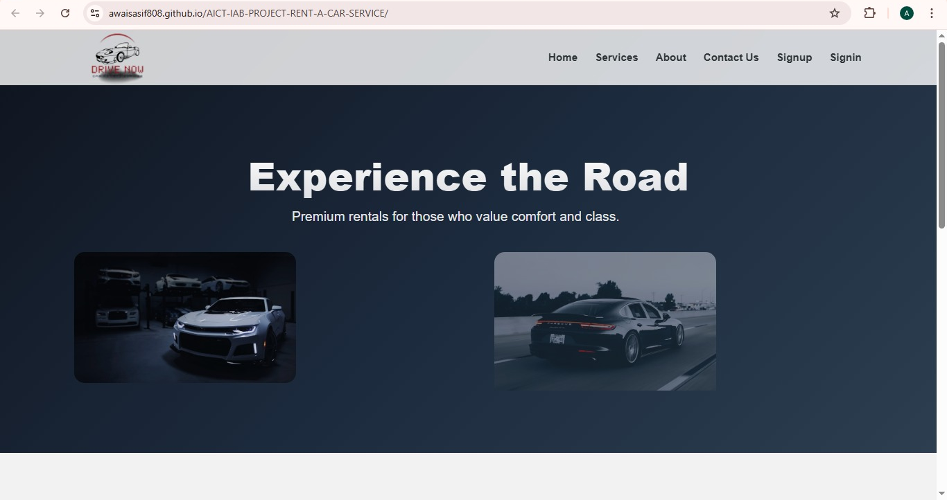

Sign In/Up Page
Sign up page is the page that is required if the client first time want to use the services of the company for this the client have to give some information of it so that he may create an account on the website of the company.
Link:https://awaisasif808.github.io/AICT-lAB-PROJECT-RENT-A-CAR-SERVICE/signup.html
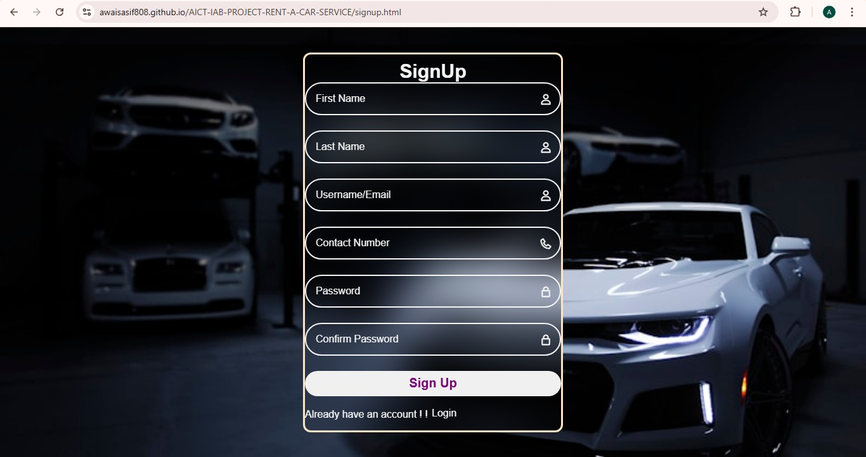

Sign in page is the page used by the user of the company if he had an account on the website but he wants to login on the website. For this purpose, he has to put only the email account and the password that he has created when he was trying to create an account on the website to use the services of the company. Sign in page demands less information from the users this is the page to authenticate the users only.
Link :https://awaisasif808.github.io/AICT-lAB-PROJECT-RENT-A-CAR-SERVICE/sign.html
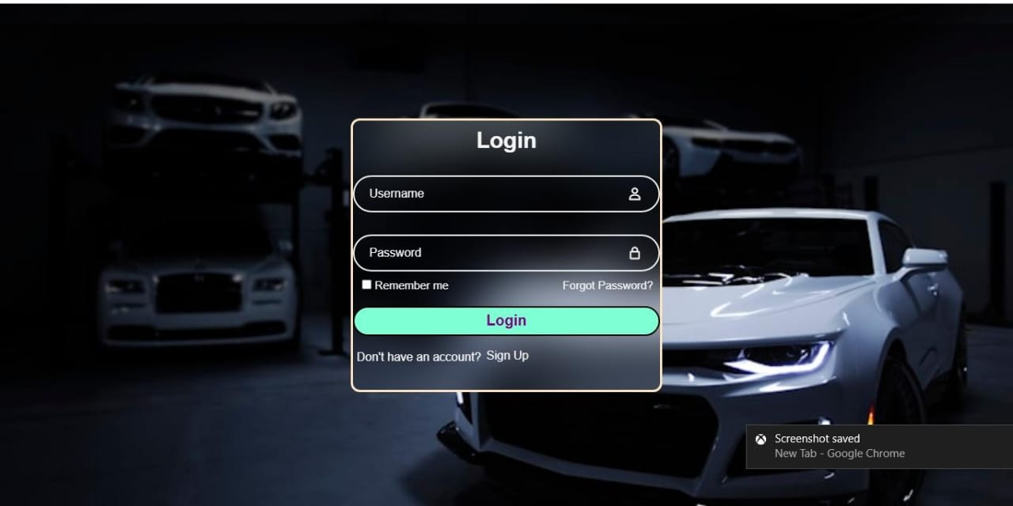

Contact us Page
Contact us page of the website is used to for the clients to contact us using their Emails or phone number if they are facing any issue in our service. In any annoying condition they can contact us to solve their problem about the car and the service. In this page they can also gave us the review about our services.
Link:https://awaisasif808.github.io/AICT-lAB-PROJECT-RENT-A-CAR-SERVICE/contactus.html
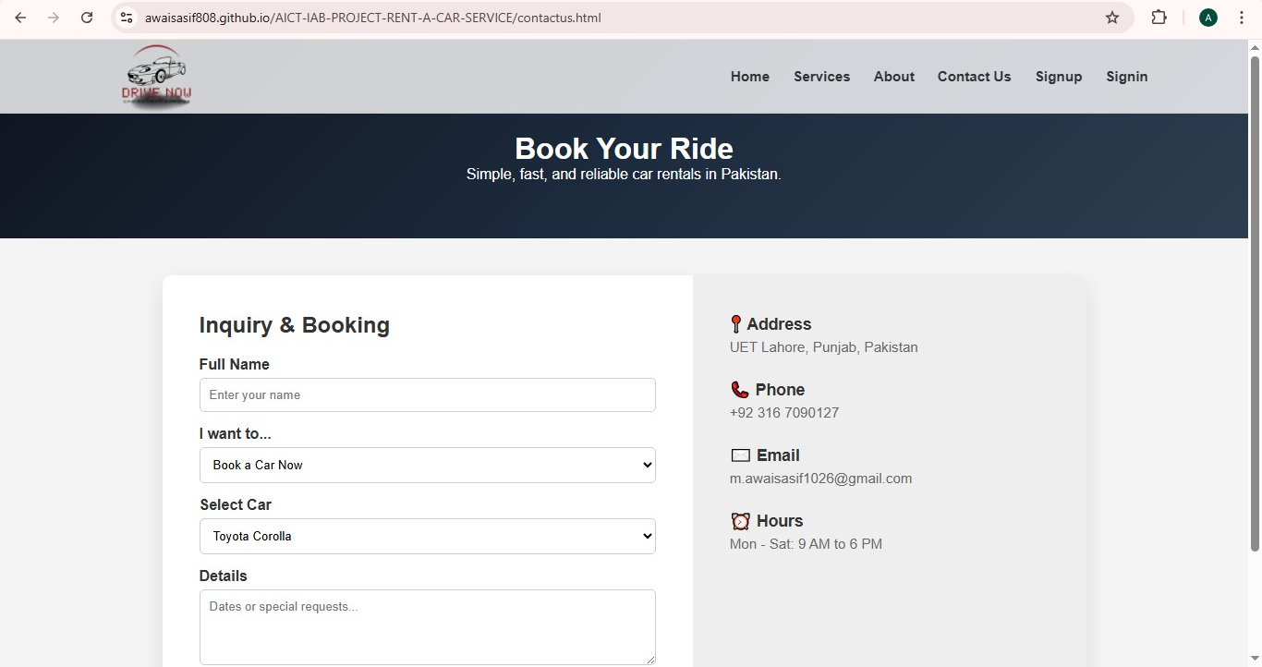

Services Page
The services page of the website is made to show the clients that how much and hoe many types of the cars we can provide to you to make the moments of their life more beautiful. The services page of the website also contains a footer having a button book now using this you can book you required car at the spot without any problem.
Link: https://awaisasif808.github.io/AICT-lAB-PROJECT-RENT-A-CAR-SERVICE/services.html
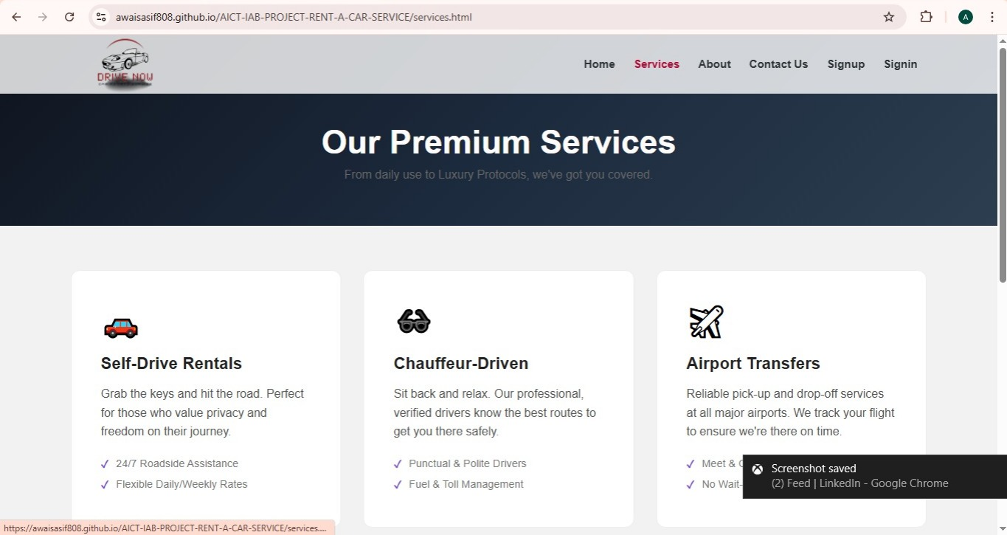

Design Choices and Layout
The most difficult work for us is that we have to make the design of the website first then we have to write the code of the website to make the front end of the website for our final project of the AICT lab. In this step web decided to make 5-6 web pages for our website first we design the home page of the website than we design the sign in and signup pages of the website then we design the all pages of the website according to that color scheme.
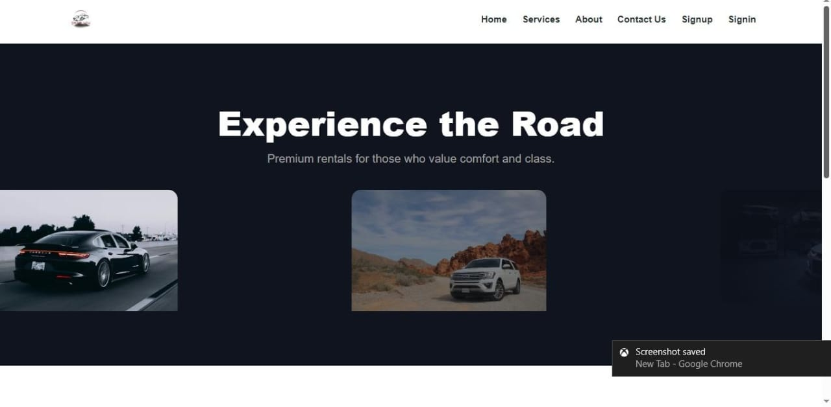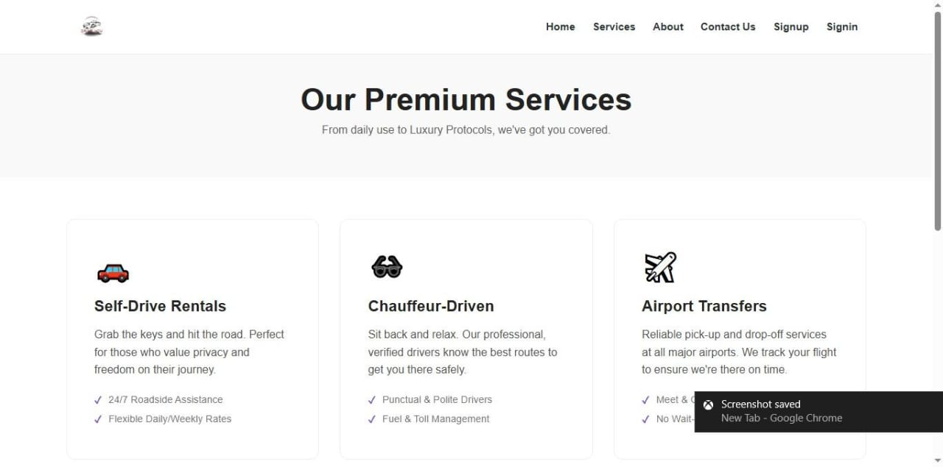
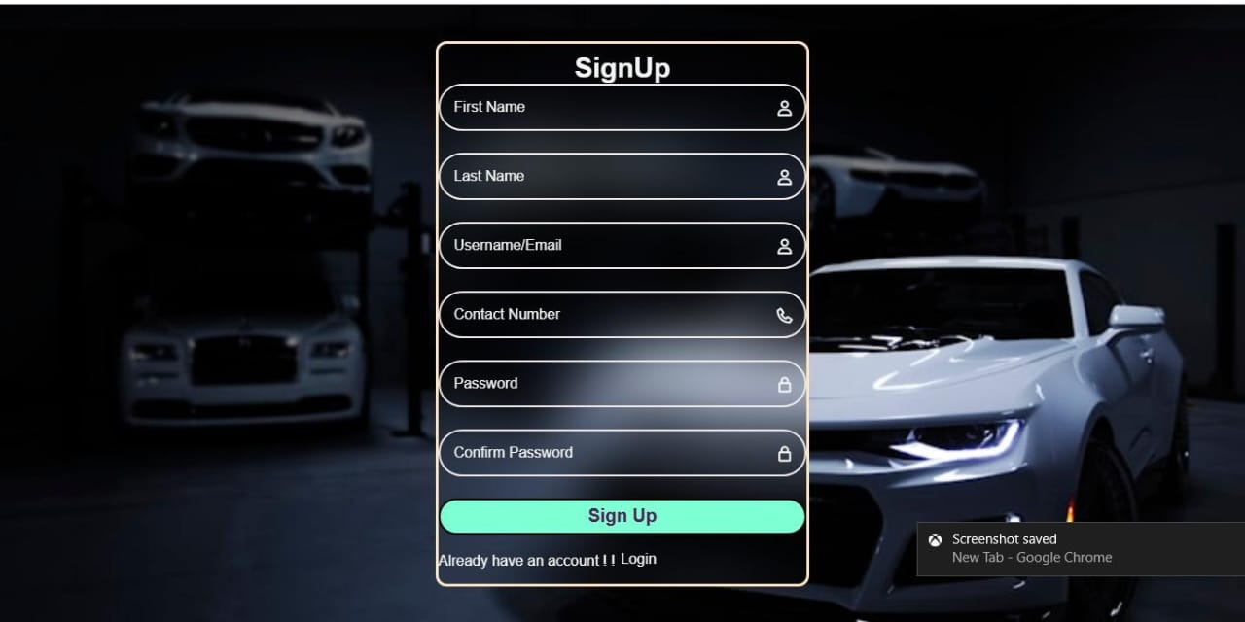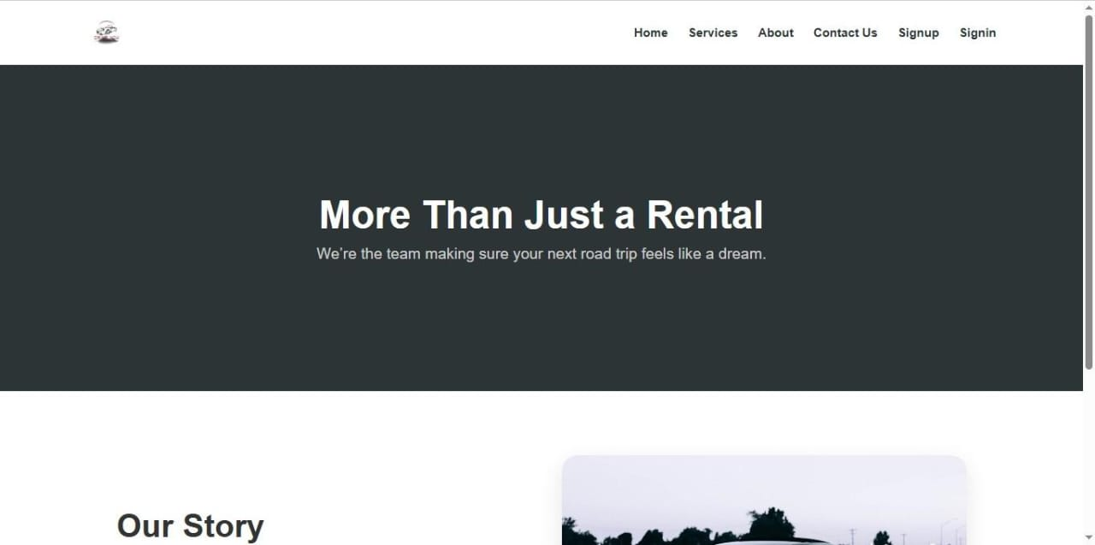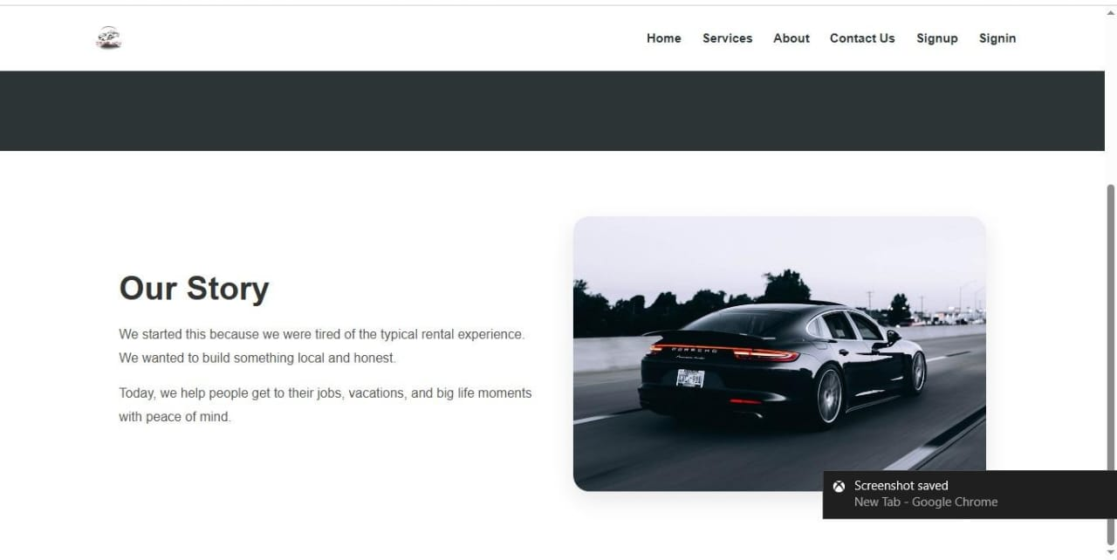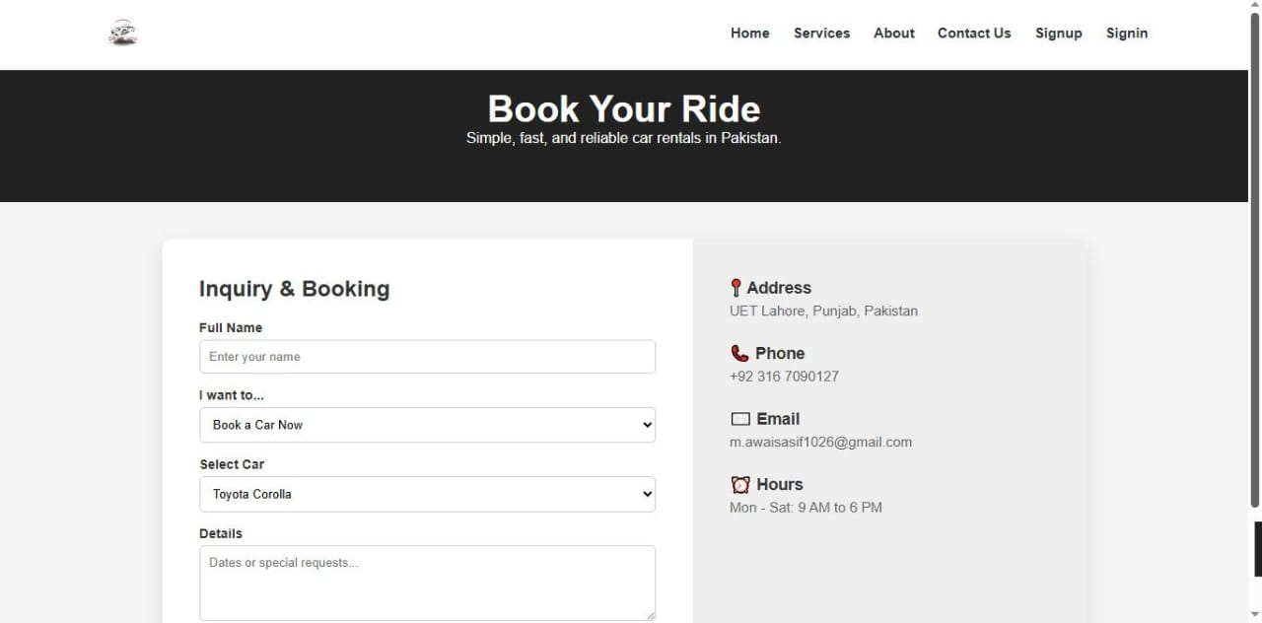

Assets Used
In this website we have used many pictures of the cars and color scheme and font families. In the navigation bar we have also used the logo of our website.

Images Used
As we know that this is a website that provides services to the clients so we have used many images of the goods in the website that we provide to our clients

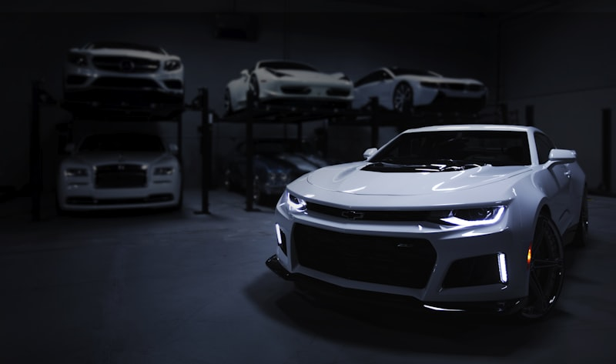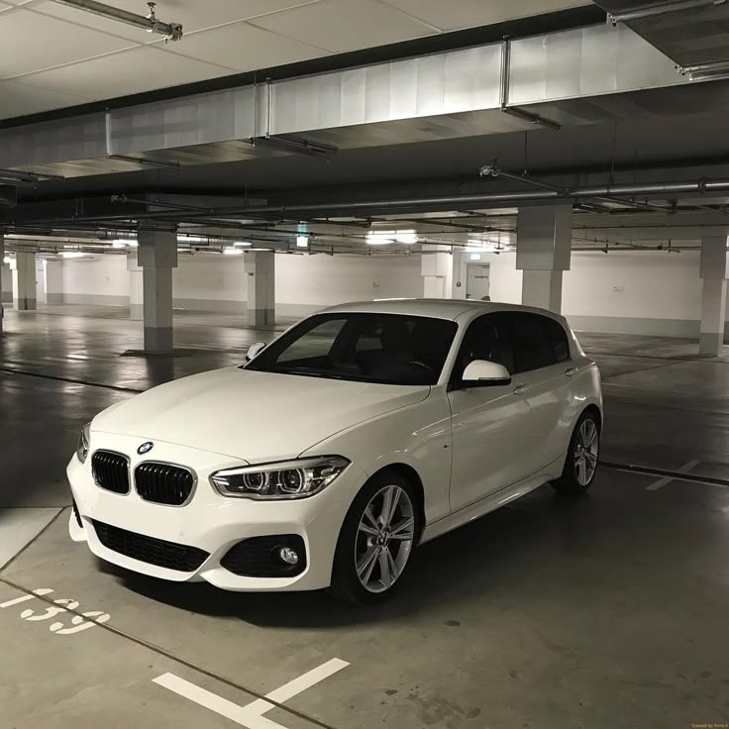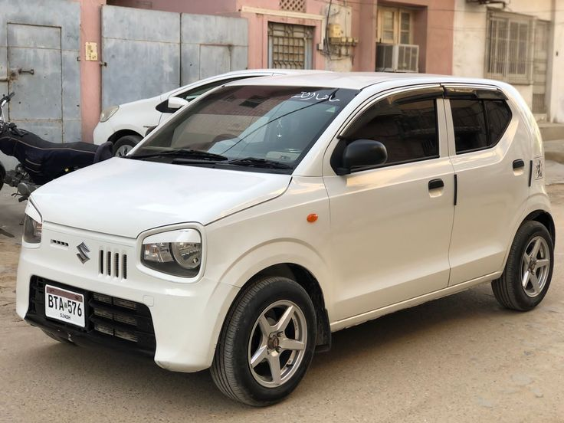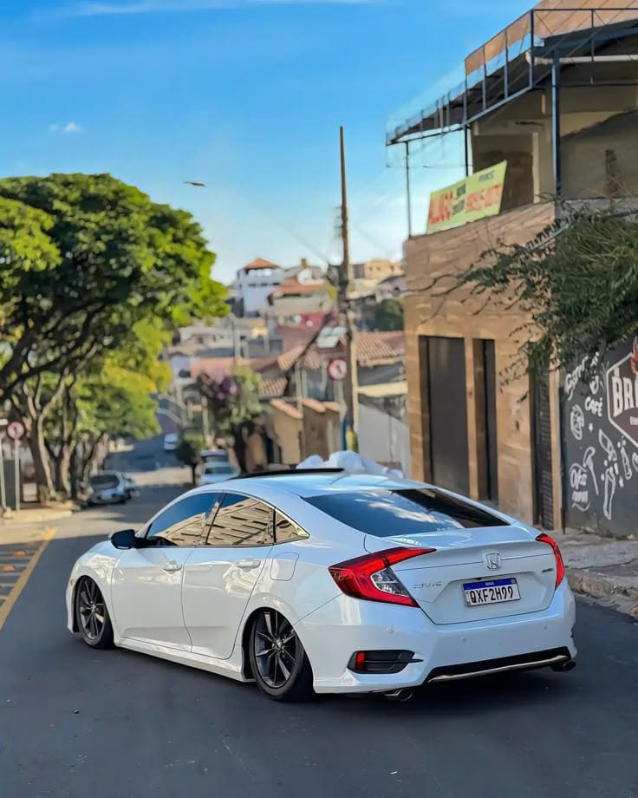

Font Used
Then font that has used in the writing the text of the website.
Font Family:
- system-ui
- sans-serif
These are the two types of the fonts that we have used in our website.

Colors Used
Colors are very important part of any website that make anything attractive. In this website we have used many color schemes such as
- rgb(0,0,0,0.05)
- rgb(255,255,255,0.8)
- white
- aquz
- #2d3436 etc

Publishing and Running of Web
After writing the complete code of the website the last step was to publish the website.
To publish website we used the git hub pages.
Link:/https://awaisasif808.github.io/AICT-lAB-PROJECT-RENT-A-CAR-SERVICE/
This is the link of our website that is the result of our hard work.

Brief Guide to Publish Web
We lived our website using the git hub pages first create an account on git hub then create a repository ant then link it with git hub desktop commit you all the code using the git hub desktop and then go to the git hub and click on our code and then go to the settings and then go to the pages and then go to the main branch of the code in the right pane of the git hub window and then then go to the commit all changes then go to the action tab and wait for deploy the website after that refresh the git hub then copy the link of the website and enjoy.

Reflection of Project
The reflection of this project is that in this project we have learned how to work in a team and work consistently in a project and how can we work together on the same work in parts to make a solution of real world problem. In this project we make the front end of a website which is used by the people to book a car on rent. In this project first we have to develop the website to make this website we use HTML and CSS that we used to develop the frontend of the website. Our course Instructor gave us the basic and advance knowledge of these two programming languages HTML and CSS.
After that we use Microsoft Word to make an explained document of our project. In this step we learned how to use Microsoft Word to make an explained document. Then we have used Microsoft Excel to store the data of the website although our website is only frontend base but we have used dummy data to show that how data we be save in excel worksheet in this we have also used many formulas and charts to show that how we can use the formulas to manipulate the raw data.
After that, we make a complete presentation of the project to explain the whole project in front of the instructor and the class. In these slides we have gave all the data about the project and these slides have enough information to explain the work that we have done in our lac of AICT.
Then, we have to represent our all the data about the project in a single animation video just in 30 to 60 seconds and then we use the pro version of a video editor to make the animation video for our project.
In this project we have learned team work, team leadership, HTML, CSS, Microsoft Word, Microsoft Excel, Canva.

Improvements
After completing the work of this project, we can also want to suggest some improvements in the website and in other works we have done in the project. The website can be converted into the real world website that can be used to book a car in rent by adding the backend in this website because this is a website having complete front end so I will work forward to add backend in this website as I learn more in future.

Improvement Task Flow

